**User Guide – Digitized Timesheet for Co-op Student**

**by Youngeun Seo and Jimmy Huang**

**Student**

**Login and Setup:**

In the beginning, HR(Brittany) needs to create a new coop student data in the Timesheet App. Once students are given their employee ID at HTC, they need to use the same employee ID and the password will be initially set by HR. They can change their password in the setting after.

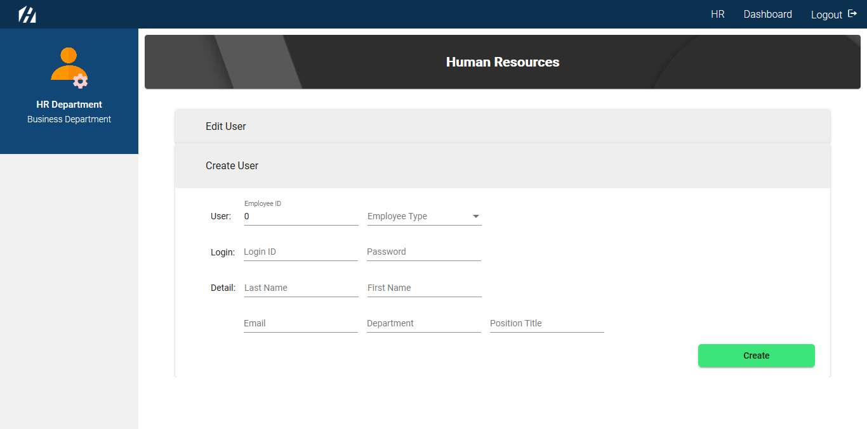

**Main Dashboard:**

The first page that students will see after successfully login will be the following screen.

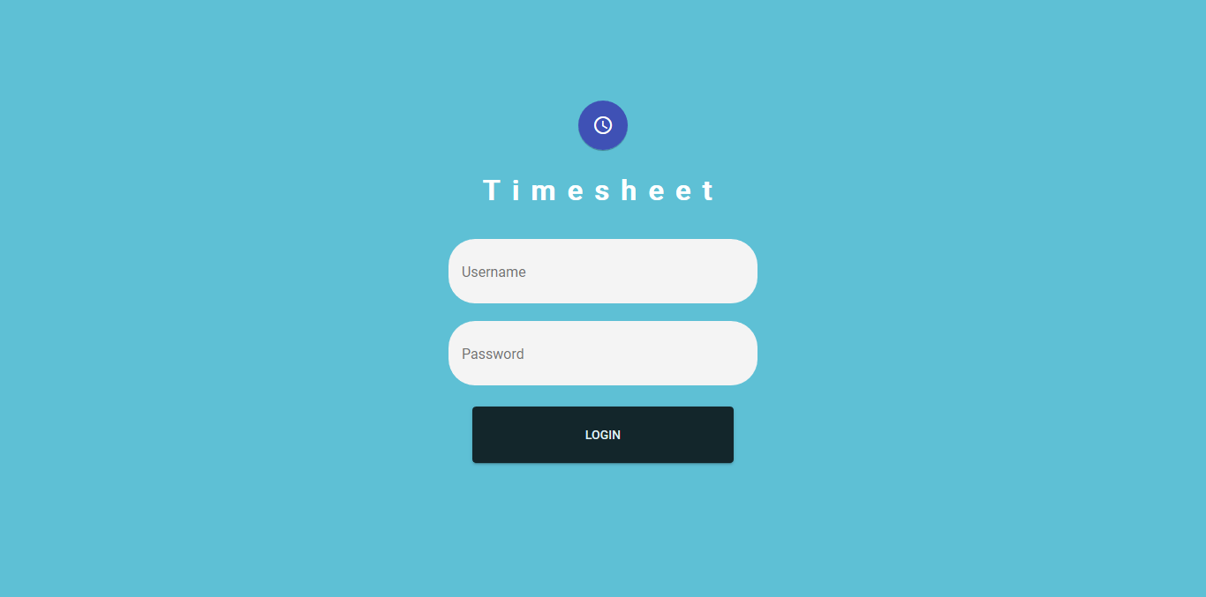

The main dashboard displays the name of the student, welcoming sign, email, position, one of the HTC values, and calendar. Logout features are accessible on the top bar. The status of timesheet is displayed on the sidebar. There will be 5 biweekly slots and the days are auto populated.

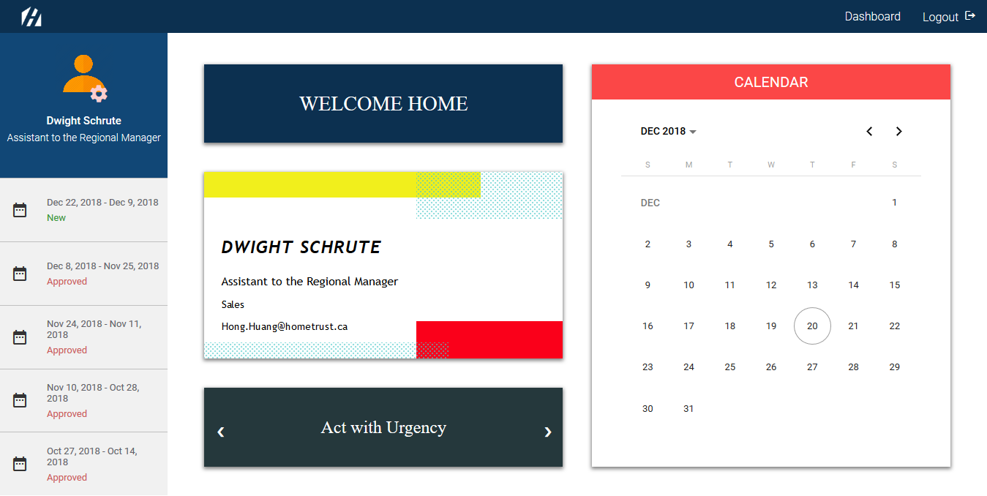

**Timesheet:**

If they click one of the timesheet slots on the side bar, the following contains 2 charts, where they can type the number of hours on each day.

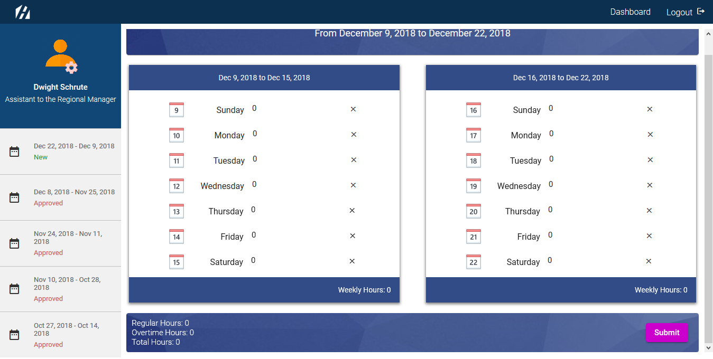

Students are restricted to input numeric values and the period only. If they enter digits that exceed 24, the following is the warning message they will see.

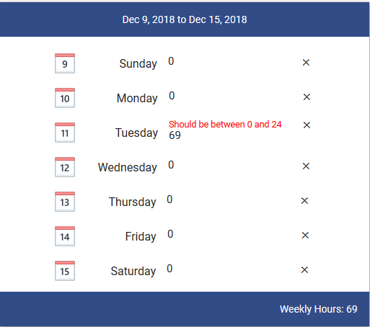

The following shows the total hours and overtime are automatically calculated.

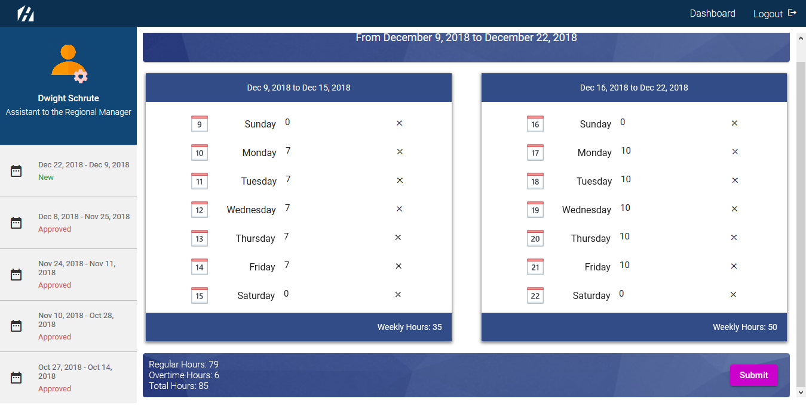

Once the timesheet is submitted, it is disabled.

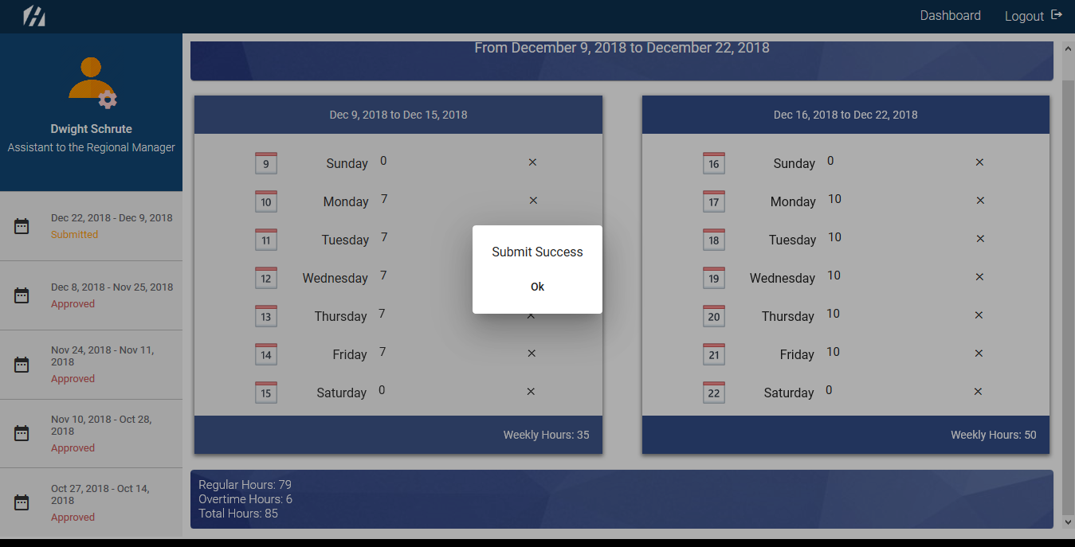

Once they click Submit button, it’s submitted to their own hiring manager and the status on the side bar changes from New to Submitted.

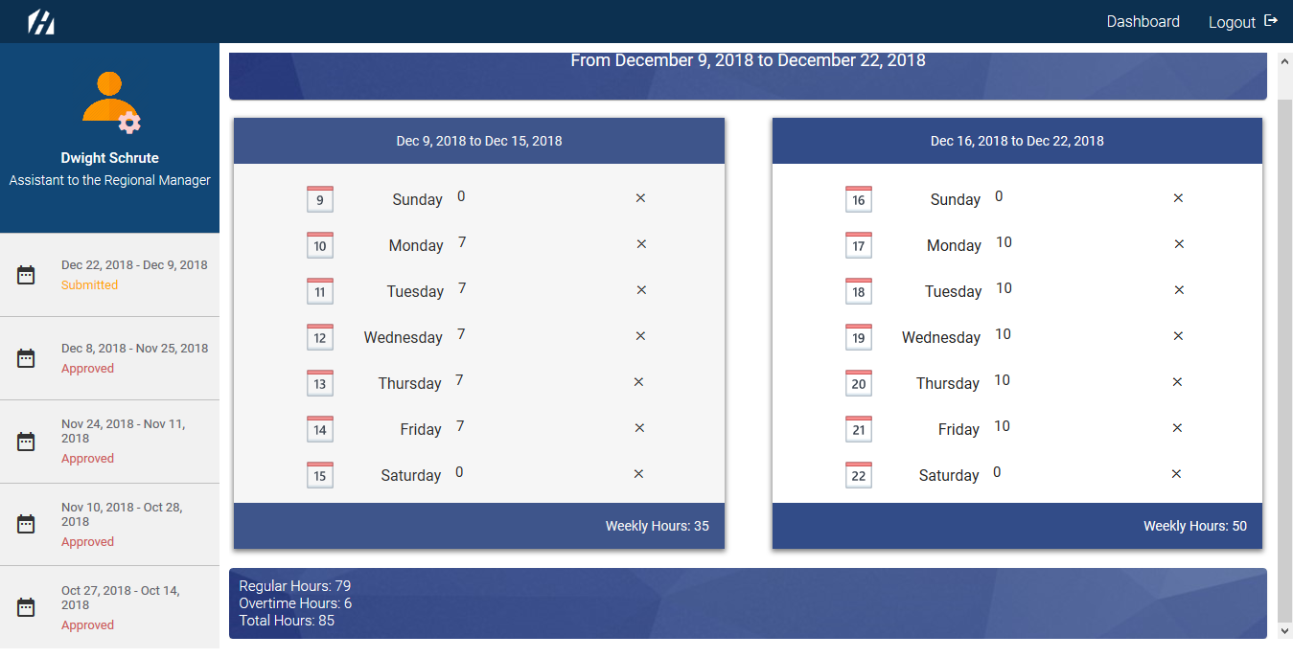

**Manager**

**Main Dashboard:**

For manager, the main dashboard will be the same as students’ dashboard except some changes in personal info and the side bar, where slots display the submission of timesheet from students.

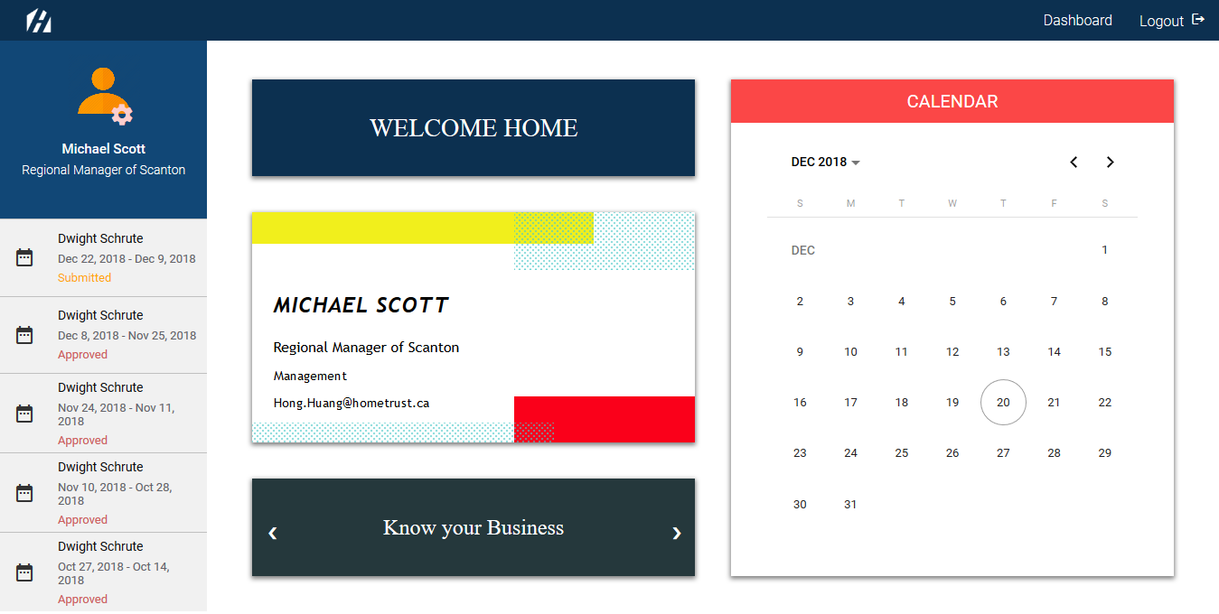

**Timesheet:**

If they click one of the timesheet slots on the side bar, the following is what a student submitted.

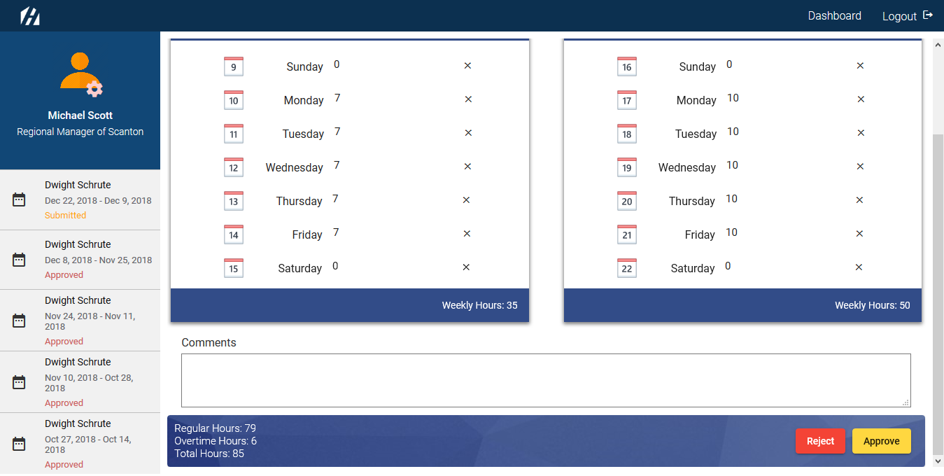

Managers can either approve or reject the submission of timesheet.

If the timesheet is rejected, students get to resubmit with the correction and the status of timesheet will be changed from Submitted to Rejected. Managers can also leave a message if necessary.

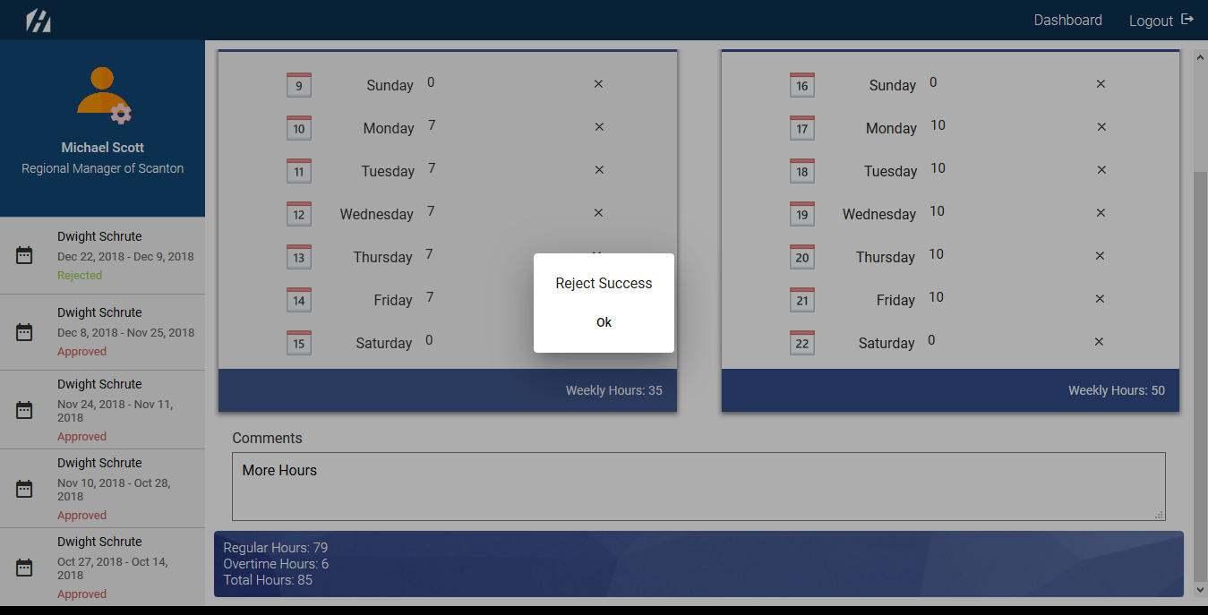

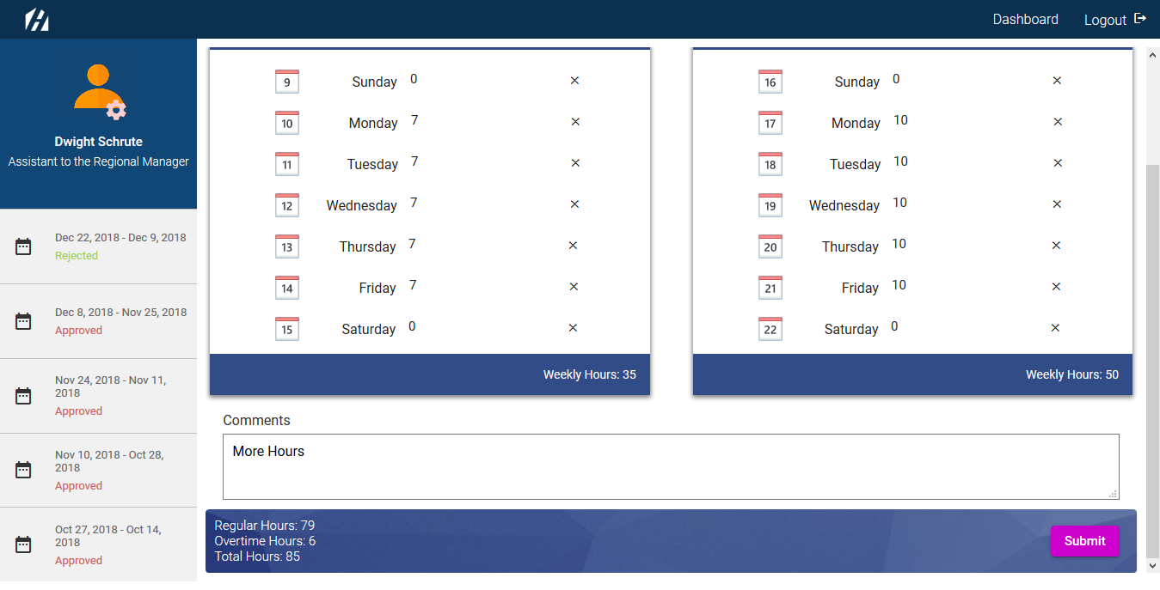

If the timesheet is approved, students see the status change from Submitted to Approved

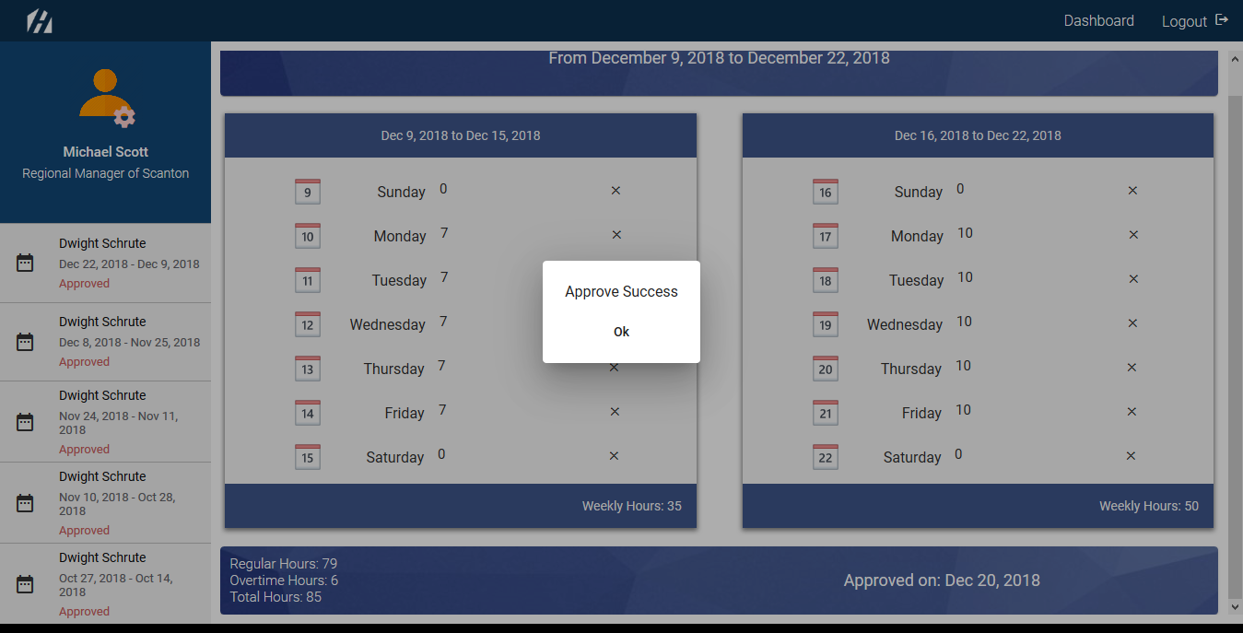

**Payroll**

**Records Dashboard:**

The following is the table that have columns of employee ID, name of students, total hour, overtime, manager approval. They can filter data by selecting the specific period of date from the calendar.

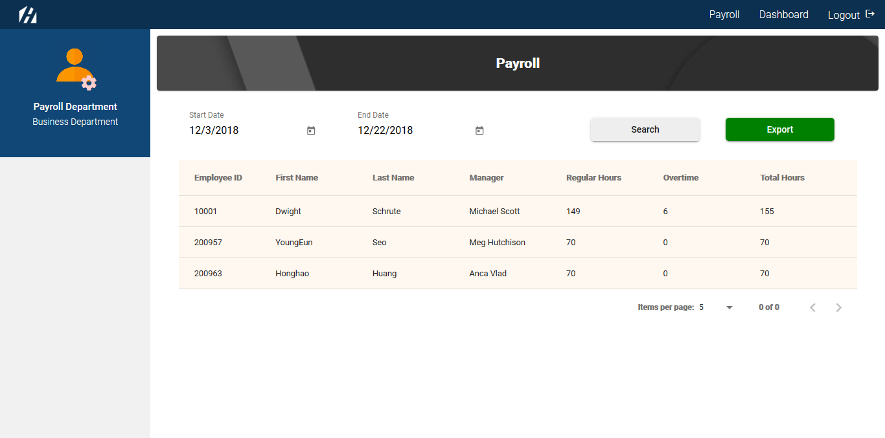

They can also export this data chart to spreadsheet by clicking Export button on the top right corner.

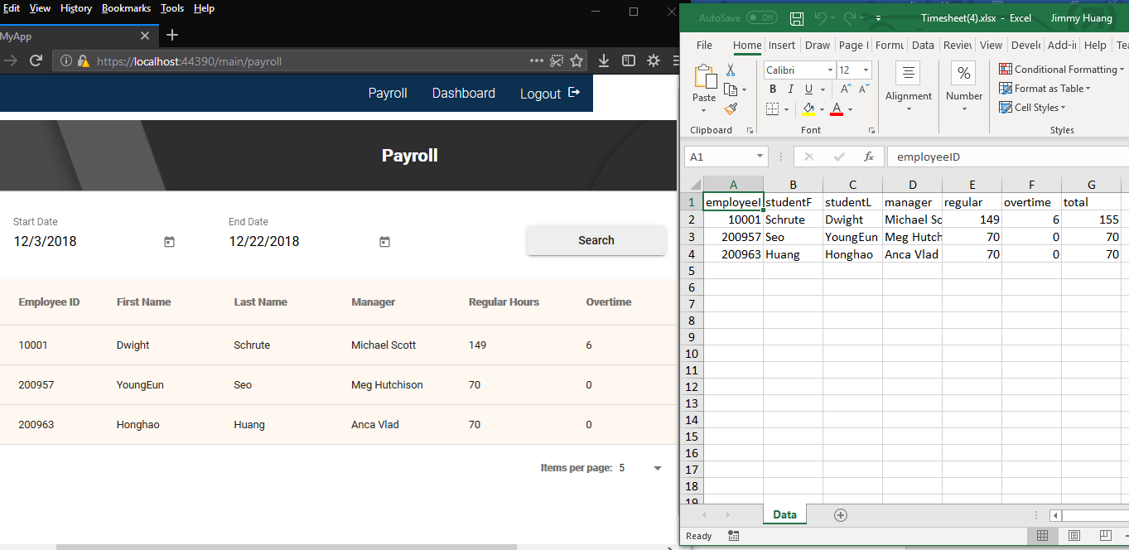

**Human Resource**

**Maintenance Dashboard:**

HR is responsible for maintaining, updating and creating a new student data.



If they want to update an existing students or manager data, they should click Update accordion bar and use dropdown to select the data. Once they select the person from dropdown, fields will be auto populated.

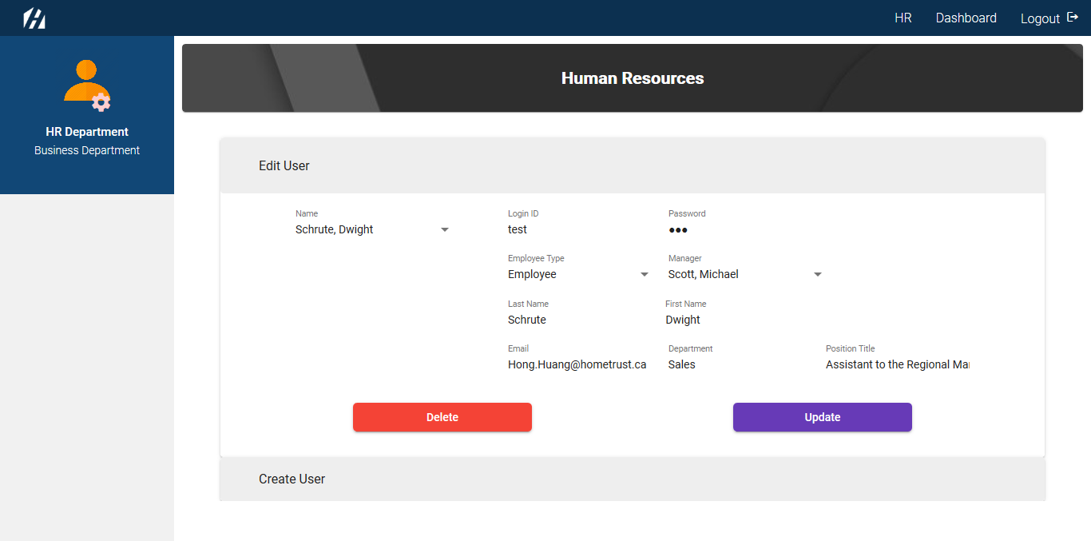

Update and Delete buttons will be on the bottom of the selected page. For the Update button, data will be updated. For the Delete button, HR can use it when students are no longer working at HTC.

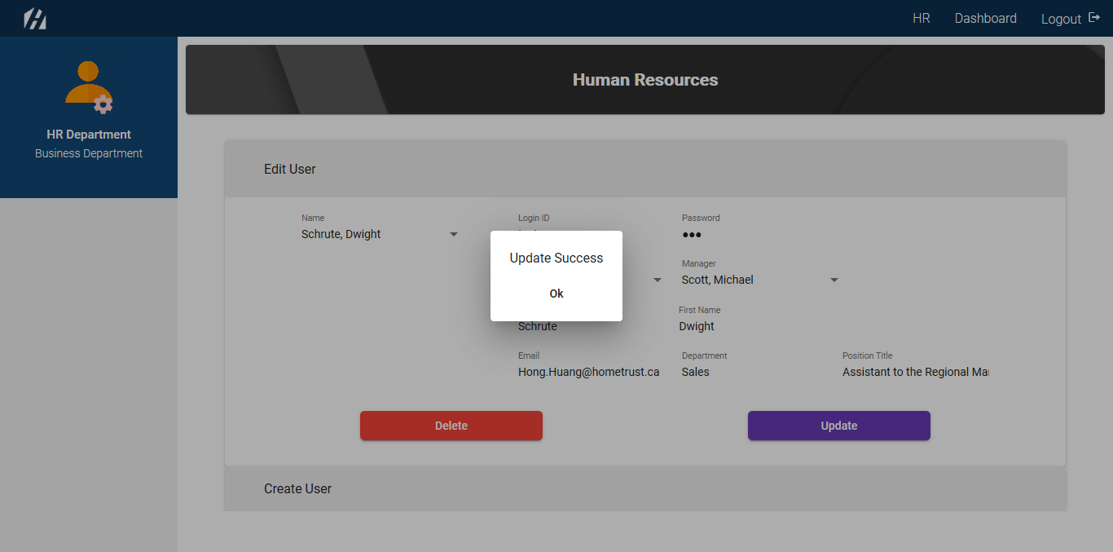

If they need to create a new user, click Create a New User accordion bar.

The following is what HR see when they click the Create a New User bar.

Create button is on the bottom of the selected page and it will create new data in the database.

